

Western University of Canada

Faculty of Engineering

MSE 2202 – Introduction to Mechatronic Design

**Team Project – Tesseract Robot**

by

Andrew Randell, Fan Kang, Lovdeep Singh, Maral Mohaghegi

Product Development File

Group 9, Prof. Naish

Date Submitted: April 11, 2018

Table of Contents

Meetings

Engineering Log-Book 4

Our Design Process 6

Final Design 24

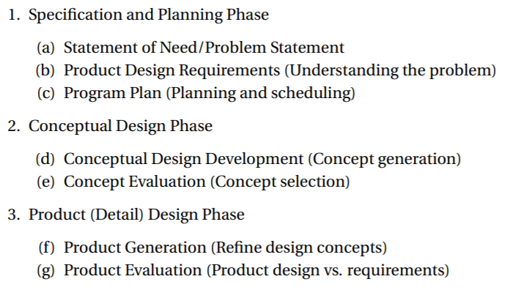

Pictures, Diagrams, Graphs

Field Diagram 9

Robot Base Photograph 12

Robot Back Photograph 13

Robot Complete Pictures 17

CAD Design 1 20

Build Progress Pictures 21

Design without Sensors 24

Omni Wheel Drive 27

Final Robot Design 27

Chassis Pictures 40

Final Design 42

Prototype 1 45

Sketches and Models

Sketch 1 (Base) 18

Sketch 2 (Lift) 18

Sketch 3 (Towers) 19

CAD Models (Base) 33

CAD Models (Lift 36

Code and Programming

Autonomous Code 23

Product Document File

**Decisions on Document File**

• We decided on an electronic format over the traditional handwritten journal. We understand the latter is standard in engineering, but find that an electronic format saved on a cloud-based service will ease communication amongst the team and make the journal more accessible to members.

• In order to maintain traditional aspects of an engineering notebook, we decided to save each page as a read-only PDF file and have any additional annotations made in red font. This simulates the permanent aspect of using pen in a paper notebook.

Our Design Process

*“Design works if it's authentic, inspired, and has a clear point of view.”* -- Ron Johnson

**Research and Design**

In this process, we analyze the objective of the game and identify design problems that we expect to face with given limitations. We research design options through the use of multiple source (online forums, engineering design lessons, past seasons) and attempt to implement this knowledge into the development of a design. We create sketches outlining every aspect of our design and analyze the strengths and weaknesses of each. We combine the best features of each design and create more sketches. We analyze these to decide on a final product.

**Modeling and Implementation**

This includes deciding on how our previously developed ideas will be implemented. We create detailed build sketches, CAD models, and simple prototypes to figure out the best way of going about each section of our design.

**Building**

We take the finalized approach to each section of our design and work towards compositing these into a final product. This involves a great deal of problem solving as we need to take into account space consumption, balance, structural integrity, and successful interaction between all parts. This may be revisited during the next stage of our design process if problems arise.

**Programming and Wiring**

We begin to test and practice controlling the functions of our design. This includes manual operation and control software development. Autonomous routines and specific driving strategies are also taken into account. Final application (ie. competitions, task performance, etc) experiences and reflections are also considered.

Date 1

## Objectives:

* Discuss goals and establish meeting times.
* Analyze the project, look at the possible tasks/problems our robot may complete/solve and document ideas on how to handle each.
* Research aspects for robot designs.

## Meeting

We successfully analyzed what processes our robot must go through to be successful in this project, gave priority rankings to each process, and brainstormed ideas that could efficiently complete the processes. After brainstorming we went back to our ideas and identified which ideas we thought would do the job well, which ideas would be mediocre, and which ideas would most likely fail.

**Robot Tasks**

(listed by priority)

## 

## Further Endeavors

* Discuss ways in which our priority tasks may be accomplished.
* Begin sketching ideas for robots and look at pros and cons of each to later combine all ideas into a single product.

Date 2

## Objectives

* Analyze field setup and discover specific problems that we feel we must overcome in our robot design.
* Look at last meeting’s table and present pros and cons to suggested solutions. Research alternatives.
* Begin sketching implementations of ideas and analyzing the plausibility and effectiveness of these designs.

## Meeting

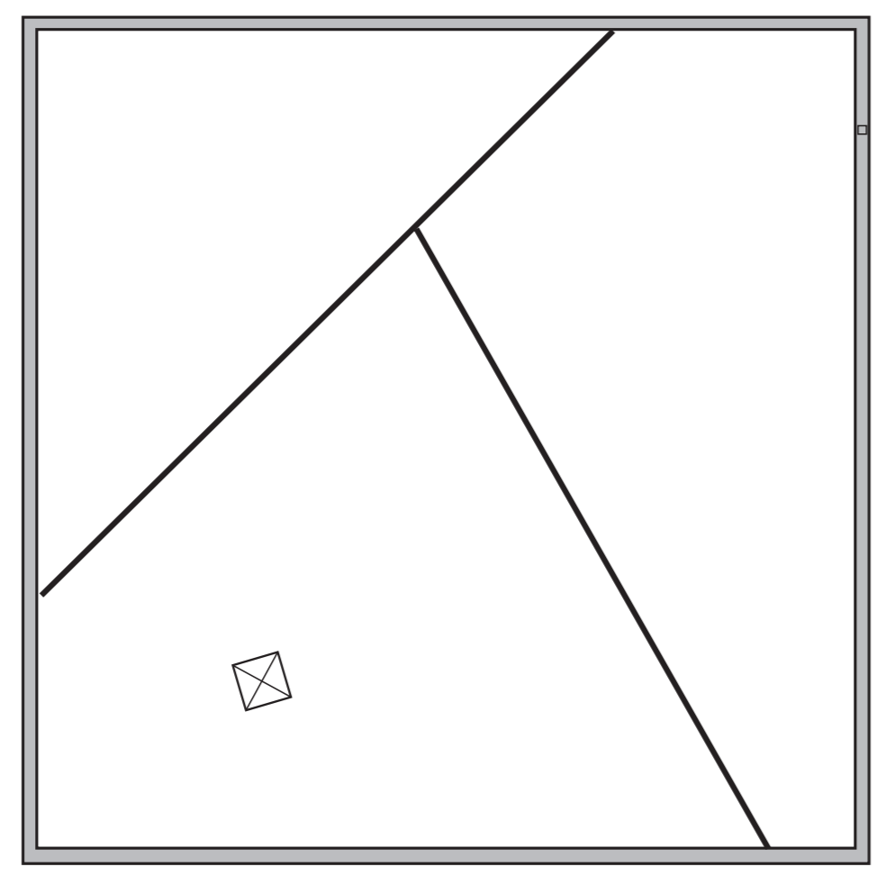**Analyzing Field Setup**

0.75inch magnetic tesseract

3.5inch wall

Pyramid Power Pack

* Encoders, line followers and other sensors that give the robot a sense of placement will be vital for an autonomous period within the open field.

**Looking at Pros and Cons for our Suggested Solutions**

* **H-Drive:** Pros: Strafing ability (ideal for lined up objects and troughts). Stronger forwards power. Cons: Tricky implementation due to center of mass calculations. Would require more motors which would not always be in regular use. We would need more omni wheels, so it would affect our budget.
* **Holonomic Drive:** Pros: Strafing ability. Can be created with current supplies. Good maneuvering. Cons: Tricky Implementation due to angling of wheels. Would require sensors for distance programming. Wheels would be prone to slipping. Not as strong.
* **Intake Top Rollers:** Pros: Quick scoring and bucky-ball maneuverability. Cons: Hard to pick up big balls and score and descore them.
* **Intake Side Rollers:** Pros: Great bucky-ball and big ball maneuverability. Cons: Not as solid and strong.
* **Low Chassis:** Pros: Easier to implement. Gives you more space to build. Cons: Would need six wheels and perhaps more than 4 motors. May not go over the bump.
* **High Chassis:** Pros: Can go over the bump with ease. Will at most require four wheels although more are possible. Cons: Loses some build space. More materials are required to elevate chassis.

## Further Endeavors

* Analyze the implementation of various designs and begin discussing best choices for first prototype.
* Discuss financial budget and parts that are essential for building such designs.

Date 3

## Objectives

* By looking at our game analysis and previous isolated ideas, develop a line of sketches detailing complete robot implementations to develop initial designs.
* Discuss previous sketches and determine plausibility, efficiency, and competitiveness of the designs. Develop ideas for changes or additions.
* Decide on a financial budget funded by the team members and organize what parts will be ordered to prepare our design.

## Meeting

Financial Budget:

**$100**

Now that we have declared our budget and the parts that we require, we may being researching the prices of these parts and order them. A financial budget is essential in many projects in engineering and allows us to better understand how to organize money and increase our project management.

We have drawn several sketches that incorporate previous discussions into preliminary assemblies while considering things such as motor use and materials.

We analyzed our sketched ideas identifying the pros and cons of each while deciding on factors of each we would like to incorporate into a final design.

## Further Endeavors

* Research the parts required and order them.
* Decide on a final design that we will be moving forward with and slowly enhance that design, modeling it in CAD software.

Date 4

## Objectives

* Finalize an order to our coach and plan to meet again when the parts arrive.
* Model our design in Autodesk Inventor, creating a CAD that we will later use to build our robot.

## Meeting

We were successful in ordering all of our parts. In total, we spent approximately $500 of our budget.

We then designed our robot in Autodesk Inventor.   
**SEE CAD MODEL**

## Further Endeavors

* Wait for parts to arrive.

Meeting 5

## Objectives

* As our parts arrived, we realized that we had a week until our first competition. We decided to build according to our CAD model and hope to have a base done for this meeting.

## Meeting

We completed our first base as a team. Although the base was not completely stable, we acknowledged our time constraints and felt it was feasible for now.

Meeting 6

## Objectives

* Research and gather data from our previous competition to design a robot that may accomplish most of the tasks in Toss, while performing said tasks well.

## Meeting

We found valuable information from the VEX Forums and we created sketches of how ideas of a new design for our robot.

**Sketch 1: Base**

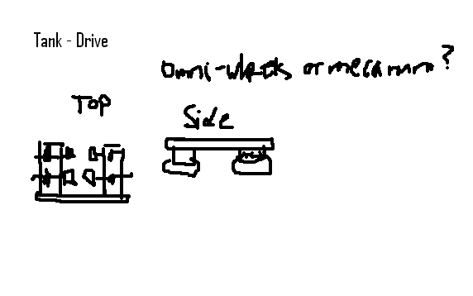

**Sketch 2: Lift**

Meeting 8

## Objectives

* Research different types of drives and write out ones that we will consider.
* Design each drivetrain in CAD software in order efficiently see pros, cons and successfully test each of them.

## Meeting

**Skid Turn Systems**

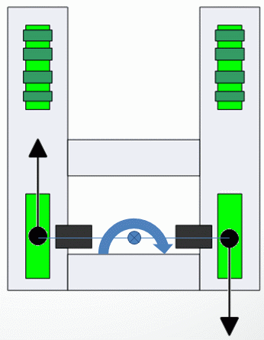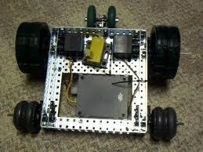

**2 wheel drive**-

This type of drive has only two wheels driven,

each wheel

driven by at least one motor.(

A.K.A.

2 wheel tank)

Pros-

Cons

easy to change gear ratios very flexible

only uses 2 motors

easier to control during autonomous period easy to repair

Can mix the wheel sizes of the driven and non-driven wheels

Not easy to push from side if traditional wheels are used

can be difficult to skid turn and may require omni wheels on the non-

driven wheels

the non-driven wheels take weight off of the drive wheels the pivot point is between drive wheels

does not climb field obstacles

(ramps,

steps,

etc.)

well

**4**/**multiple wheel drive**-This type of drive has multiple wheels that are driven either directly by

a motor or by gears or by chain and sprockets. (A.K.A.

4 wheel tank)

every wheel contributes the traction

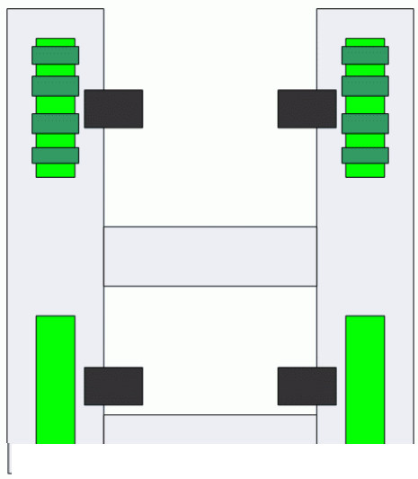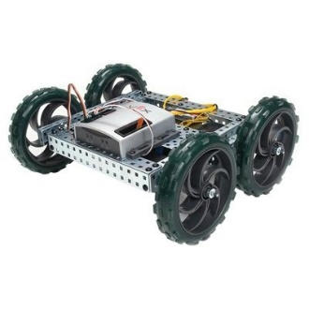

pivot point is at the center of the drive system can utilize multiple motors

effective when climbing field obstacles

Not easy to push from side if traditional wheels are used

if gears are used the distance between drive shafts are determined by the gears used

multiple motors draw more current and use up motor ports on

controller

Can be more difficult to repair and more components to fail

all the drive wheels need to be close to the same size or they will fight with one another

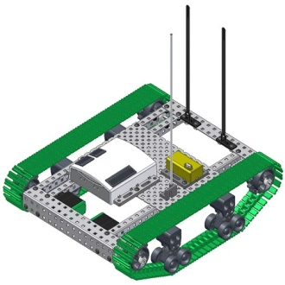**Track Systems** – This type of drive uses the VEX track kit [(**P/N:** 276-2168)](http://www.vexrobotics.com/276-2168.html) and can be driven by 2 motors or multiple motors,

Pros

Cons

good contact with driving surface

pivot point is at the center of the drive system can use only 2 drive motors or multiple motors extra traction treads are available [(**P/N:** 276-2214)](http://www.vexrobotics.com/276-2214.html) variable lengths between drive shafts

able to climb over field obstacles

the standard track lacks traction on some surfaces

the distance traveled per rotation is limited by the size of the drive sprocket ( note some teams

have used the larger high strength chain sprockets, [**P/N:** 276-2252](http://www.vexrobotics.com/276-2252.html) as drive sprockets to over come this limitation.)

can slip when pushed from the side.

**Multi-Directional systems**

**Holonomic systems** This type of system uses wheels with rollers on them and by placing the rollers at an angle to each other and powering each wheel with a motor, the force vectors between wheels can be changed. This allows the robot to move in 2 different planes and rotate. The two types of roller wheels used for this purpose are the omni directional wheels (sample [**P/N:** 276-2185](http://www.vexrobotics.com/276-2185.html)) and the mecanum wheels ([**P/N:** 276-1447](http://www.vexrobotics.com/276-1447.html)). The omni wheels are usually placed on the corners of the robot frame with the wheels placed at 45o to the corner. The mecanum wheels achieve the same action by the rollers set at 45o so the wheels can be in line with the robot frame. Special care must be used in placing the mecanum wheels so the rollers are in opposition to one another. (A.K.A. X holonomic)

Pros

can move in 2 different planes pivot

very hard to trap in a corner

(front to back and sided to side),

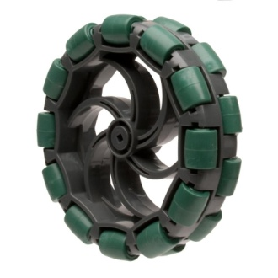plus

Cons

very effective for lining up with game pieces

there is a holonomic joystick block for ease of programming in EasyC V4

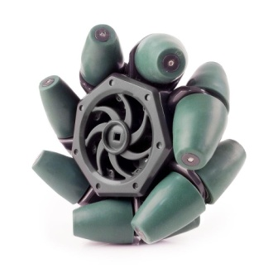requires a motor for each drive wheel

because the force vectors are always in different directions,

the

resultant force vector of the motors is never equal to the summation of the forces.

easily pushed from any direction that is not being powered

longer time may be required for driver training and driving the orientation of robot can sometimes be challenging

multiple motors draw more current and use up motor ports on

controller

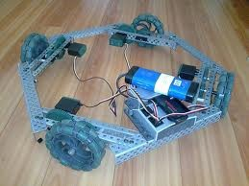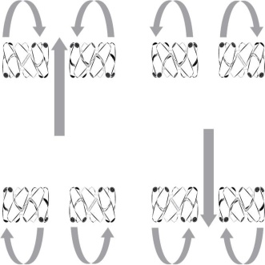does not climb field obstacles well

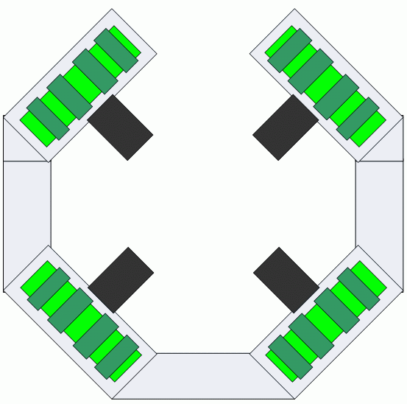

Special note:

another popular variation to the holonomic system is to orientate the omni wheels at

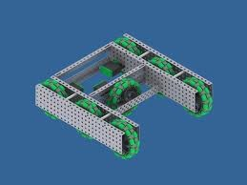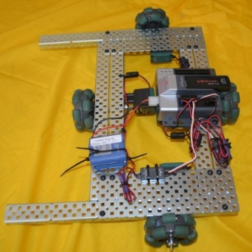90o

to one another. (A.K.A.

H holonomic)

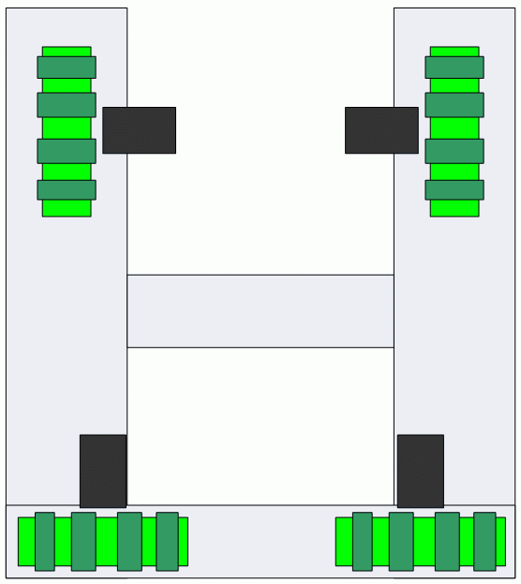

**Swerve wheel systems** –

With this type of system the wheels are in individual pods

([**P/N:**](http://www.vexrobotics.com/products/accessories/motion/276-0506.html)

276-0506)

with each wheel powered by a motor.

There are two variations of swerve wheel systems.

The swivel drive,

this system has all the wheel pods tied together by a chain and sprocket or gears

and the wheel pods all swivel in the same direction to allow 2 planes of movement and they can

pivot in a tank skid method.

The crab drive system has each wheel pod

(or pair of wheel pods)

controlled by a motor to allow motion in to 2 planes of movement and they can pivot in tank skid

method,

conventional steering,

and quadrasteering

(4-wheel steering).

Pros

can move in 2 different planes pivot

very hard to trap in a corner

(front to back and sided to side),

plus

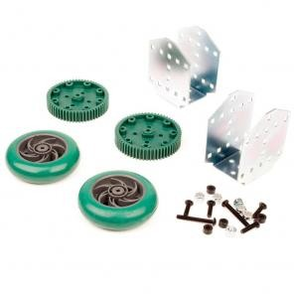Cons

very effective for lining up with game pieces not pushed from the side easily

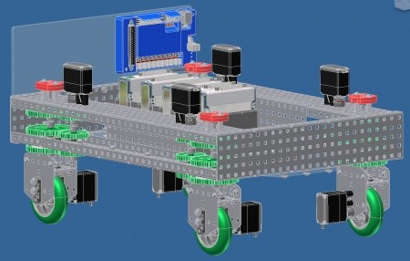can climb field obstacles

requires a motor for each wheel and motors to activate the swerve action

many components that can fail,

most complicated of drive systems

if wheel pods become out-of-sync,

driving become very difficult

multiple motors draw more current and use up motor ports on controller

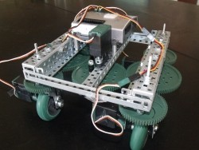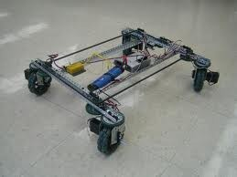most designs have a higher center of gravity

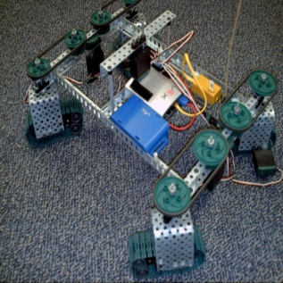

Differential “car steering” drive system

This type of system is very seldom used on robotic drive systems and is the type which is used in the drive systems in cars. This type of system requires the advanced gear system kit ([P/N: 276-2184](http://www.vexrobotics.com/products/accessories/motion/276-2184.html))

Pros

• can provide a drive system powered by only 1 motor

• allows drive wheels to spin at different rates

• can provide “car-like” steering

Cons

• requires an independent steering mechanism

• drive connection is a plastic gear rather than a metal drive shaft

• there is no conventional drive function block, although an arcade block could be modified to work

• pivot point is outside of the robot frame and requires larger turning radius

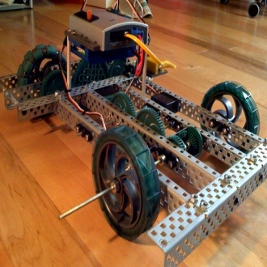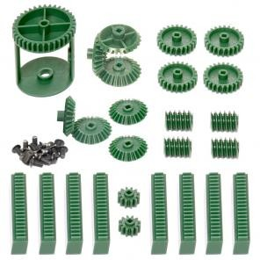

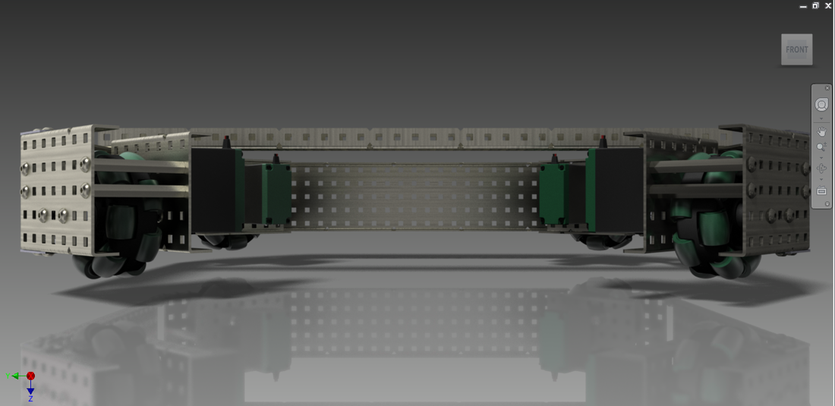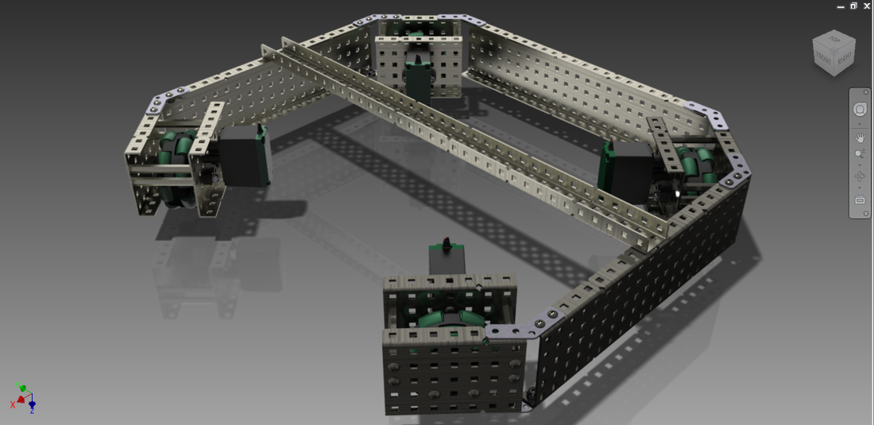**X-Drive Holonomic**

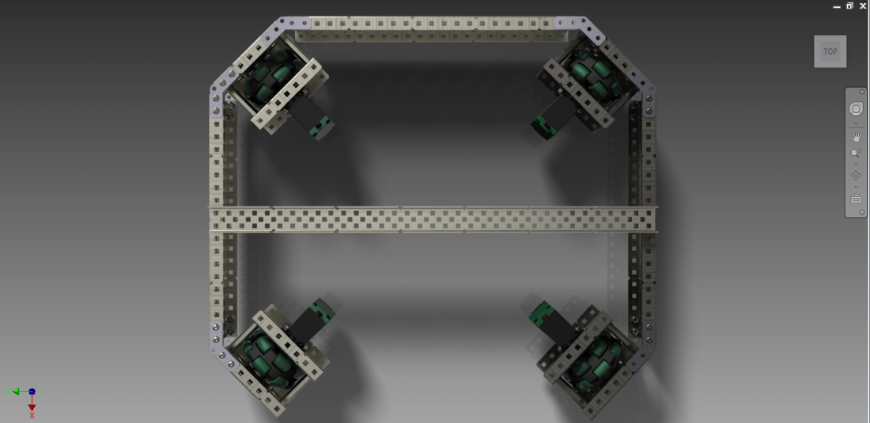

**Mecanum Drive**

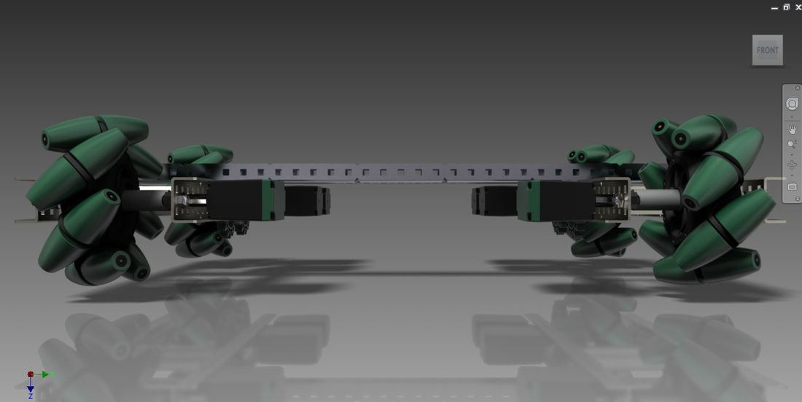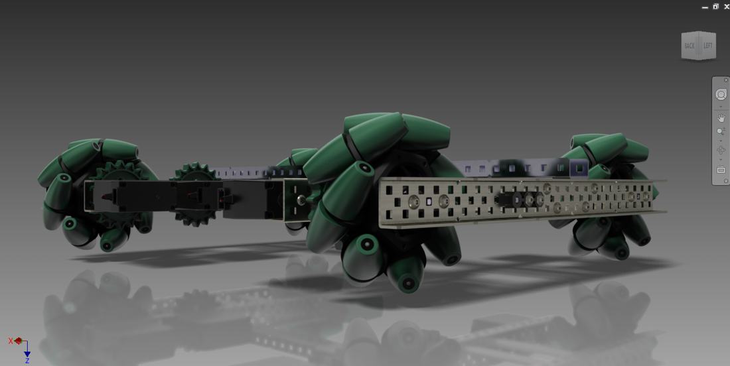

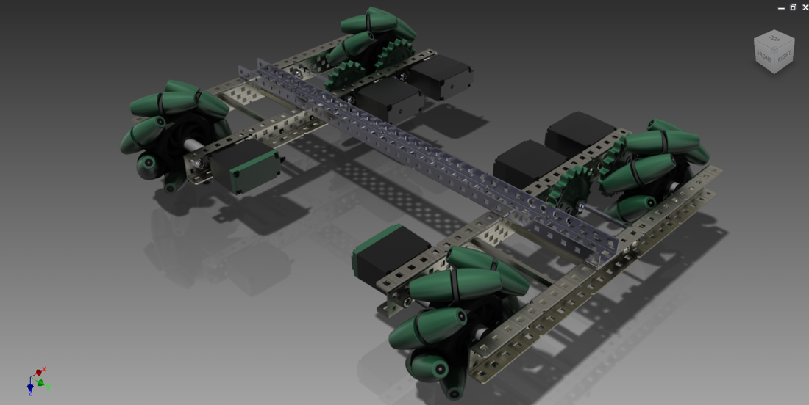

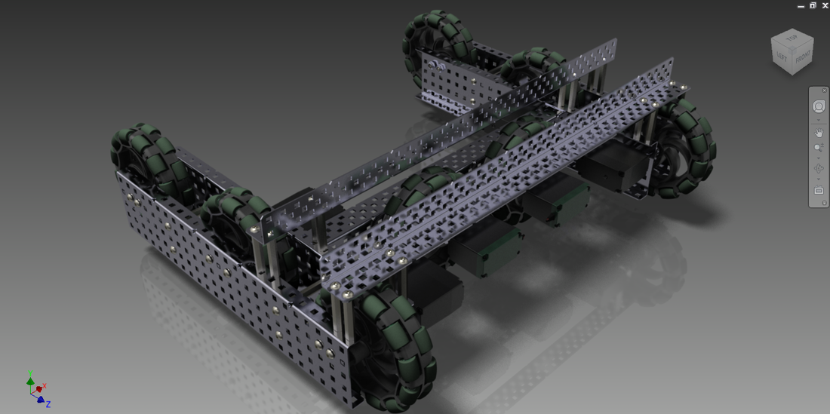**H-Holonomic Drive**

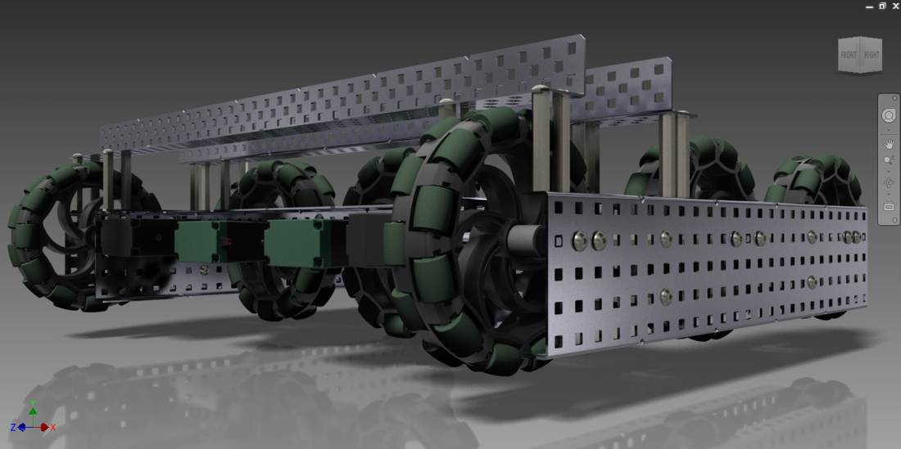

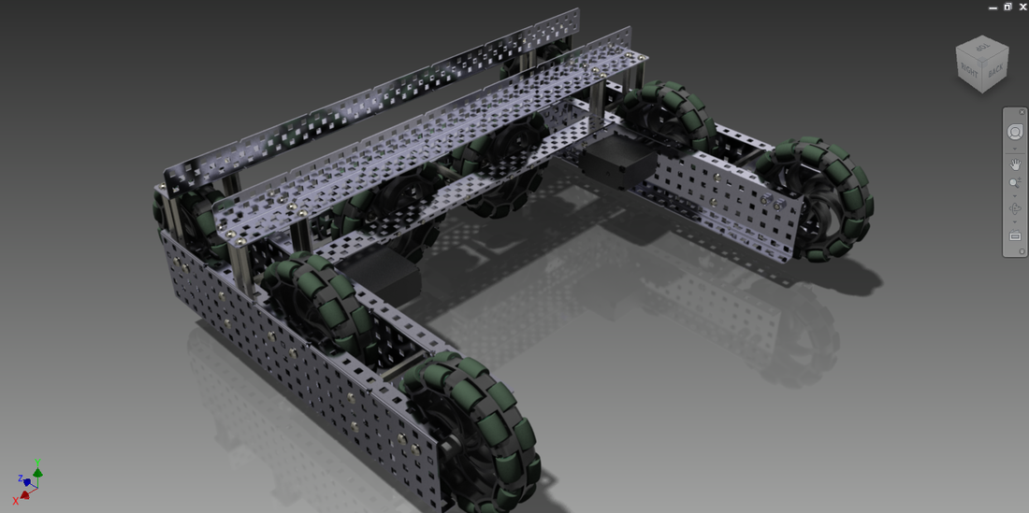

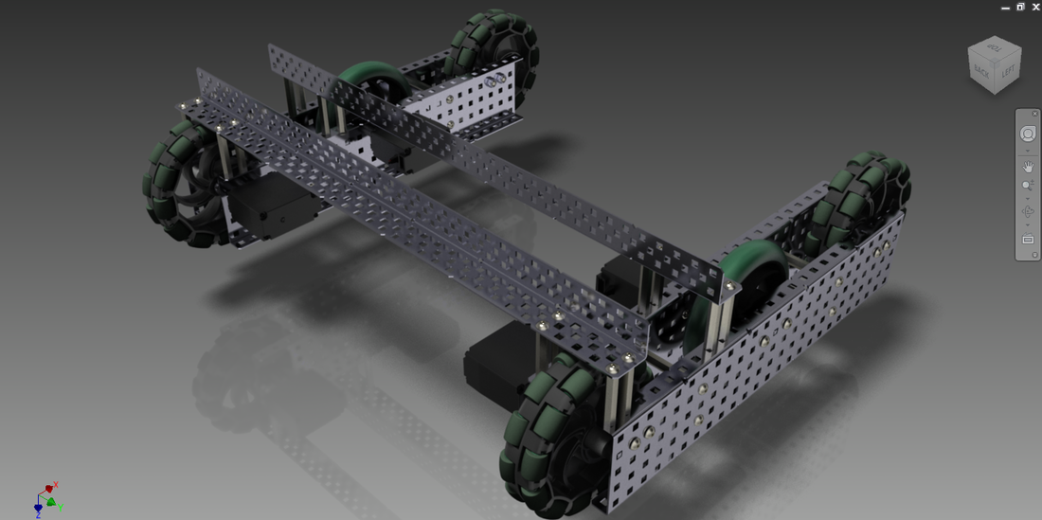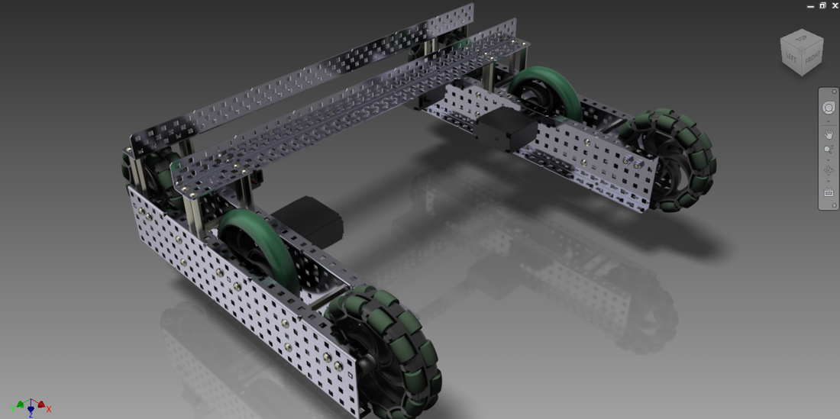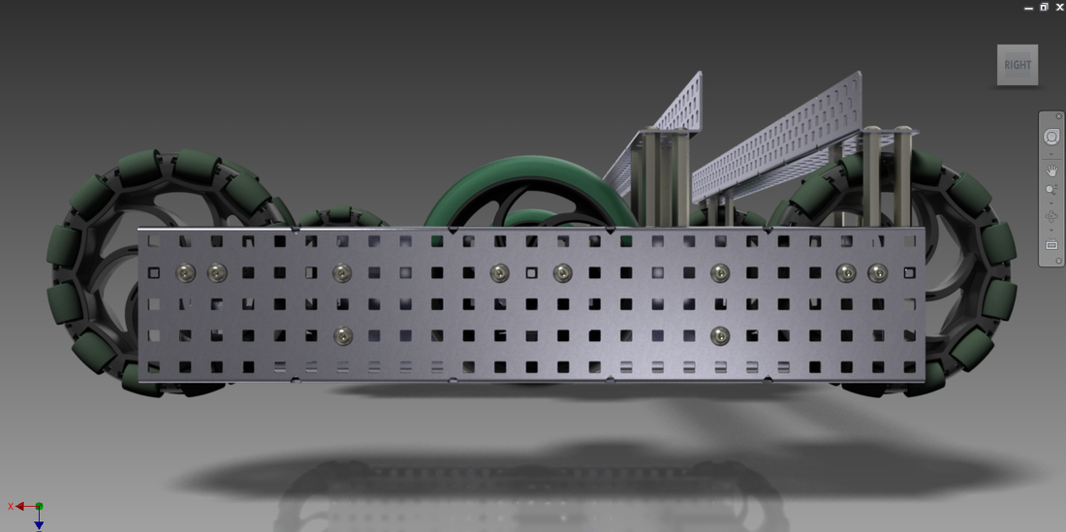**Tank Drive**

## Further Endeavors:

* Discuss lift types and design the lift we believe is best.

Meeting 9

## Objectives

* Research different types of lifts and write out ones that we will consider.
* Design each lift in CAD software in order to efficiently see pros, cons, and successfully test each of them.

## Meeting

**Lifts:**

* 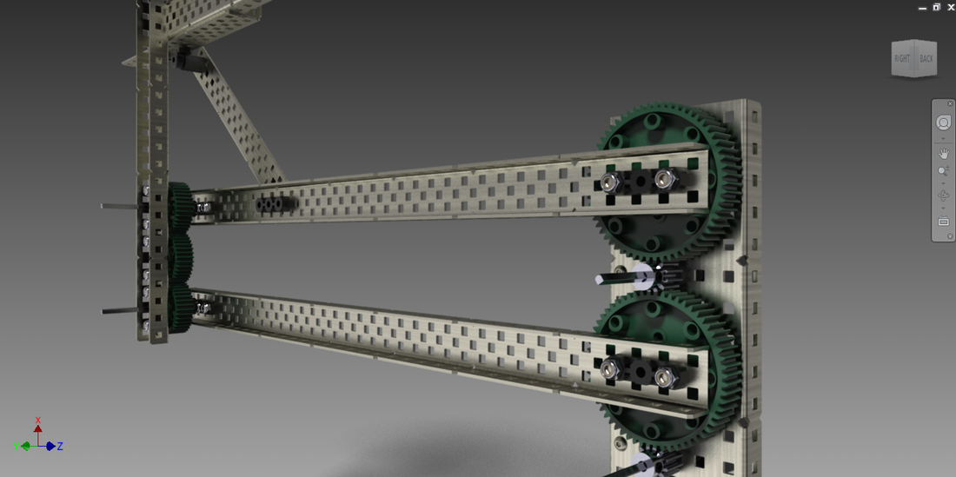**Double Reverse 4-Bar**

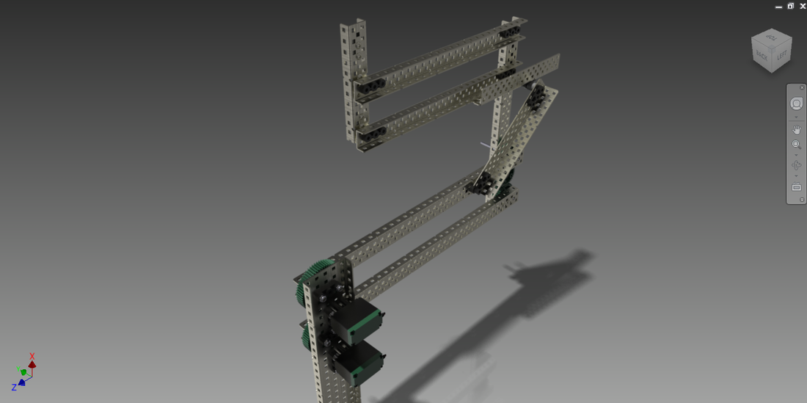

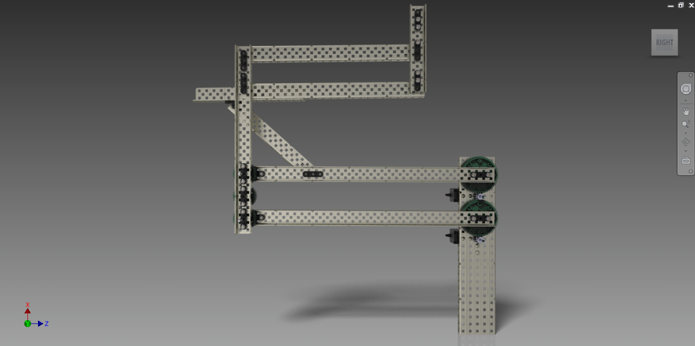

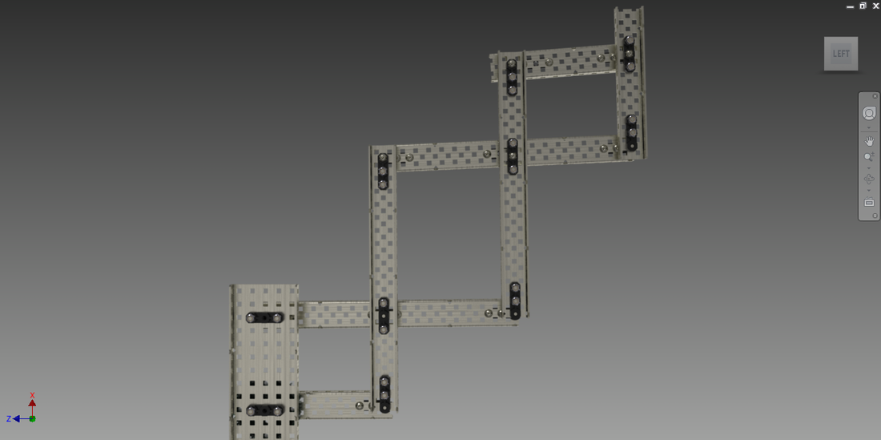

* **8-Bar Linkage**

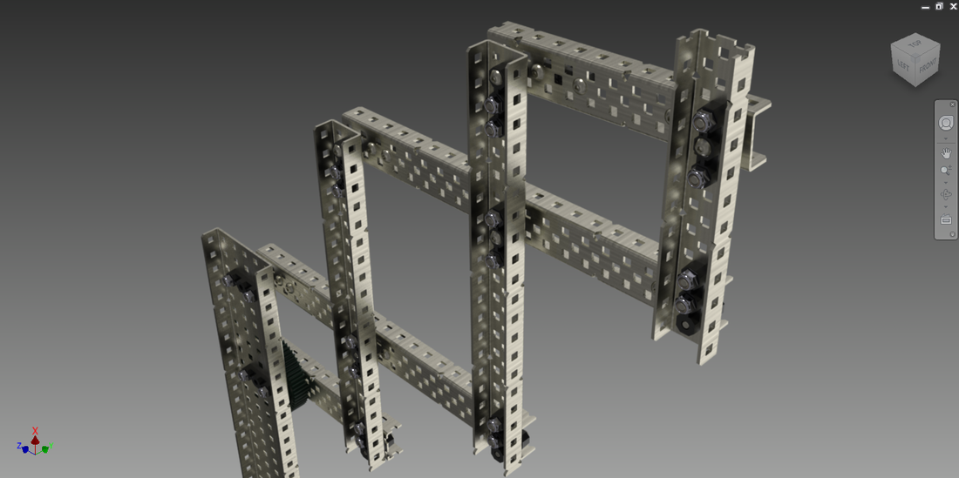

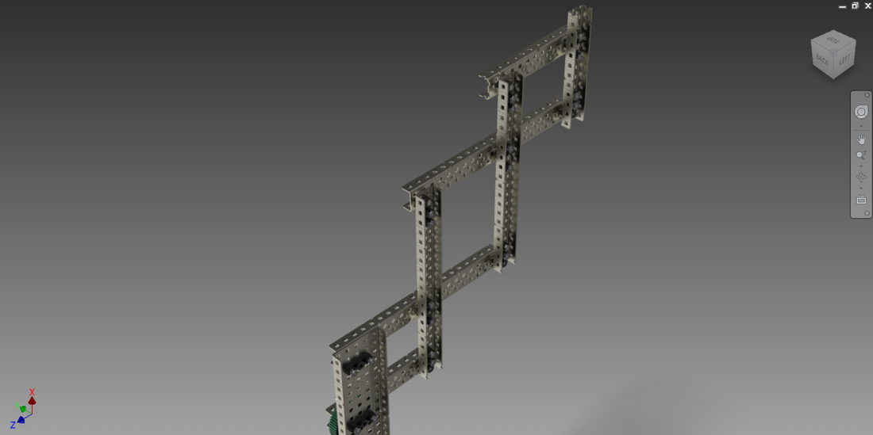

* 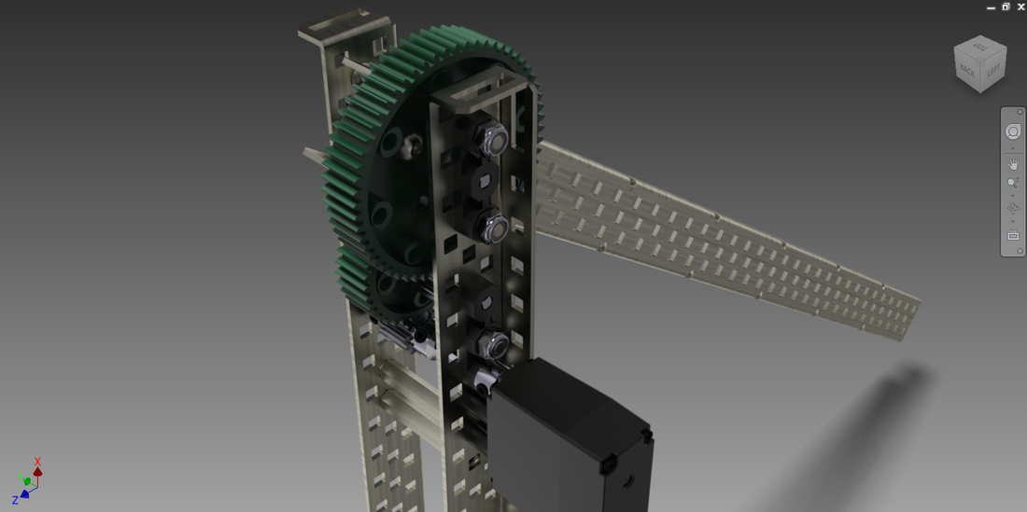**Simple Lift**

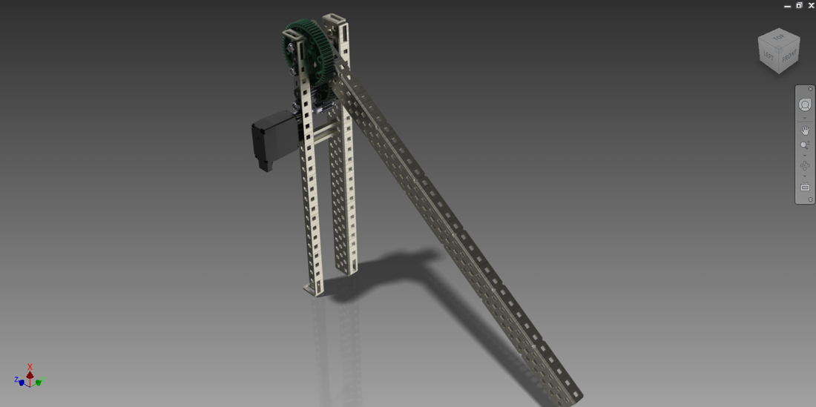

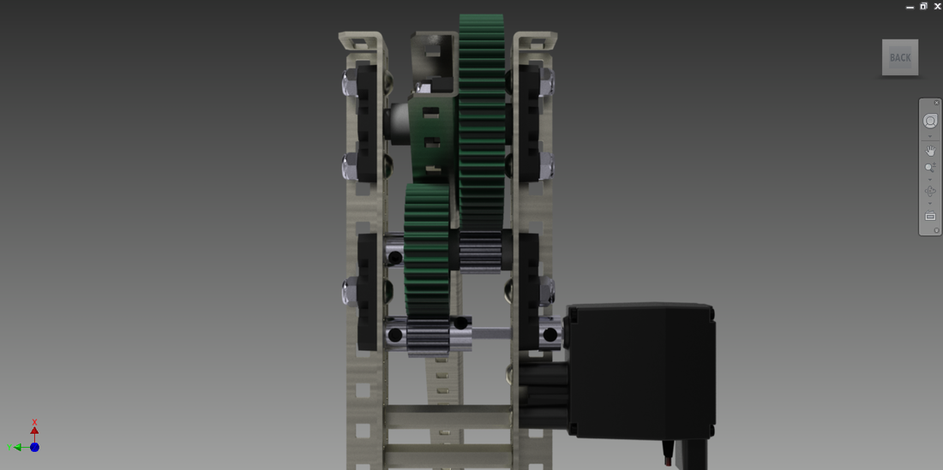

* 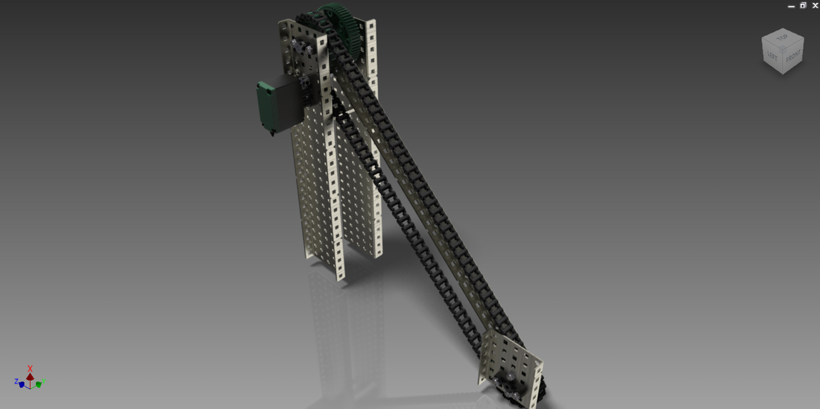**Chain Bar**

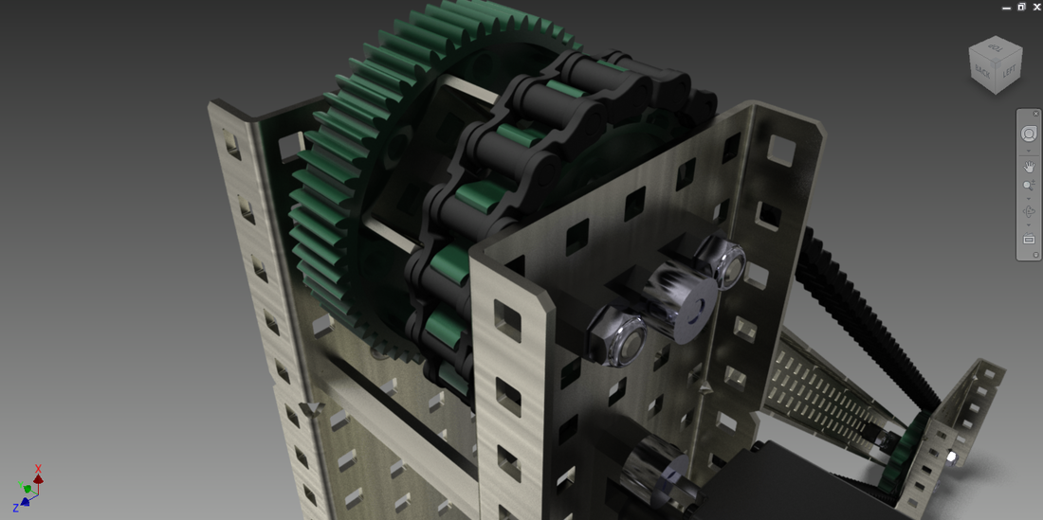

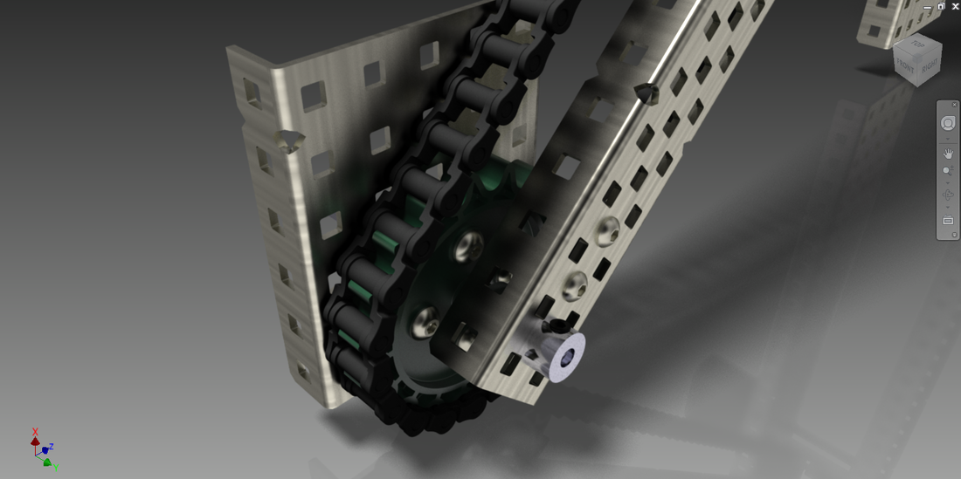

* 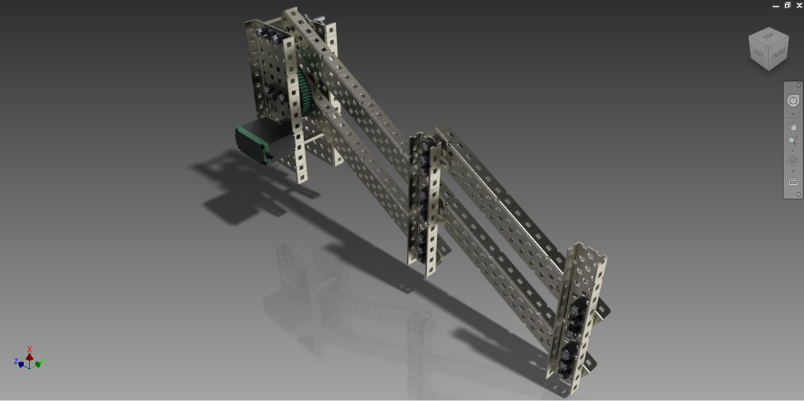**6-Bar Linkage**

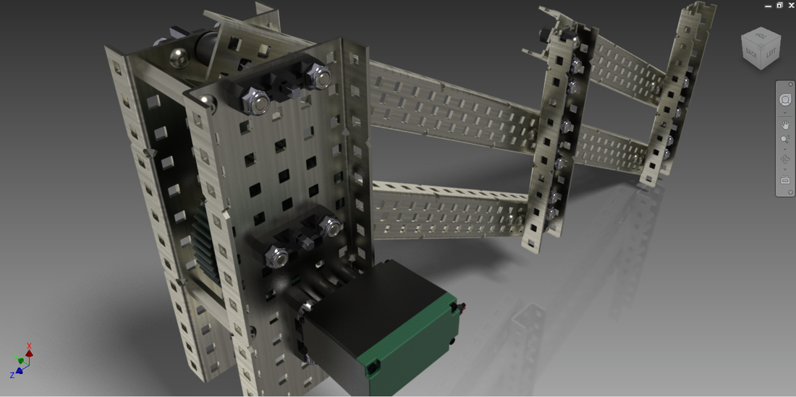

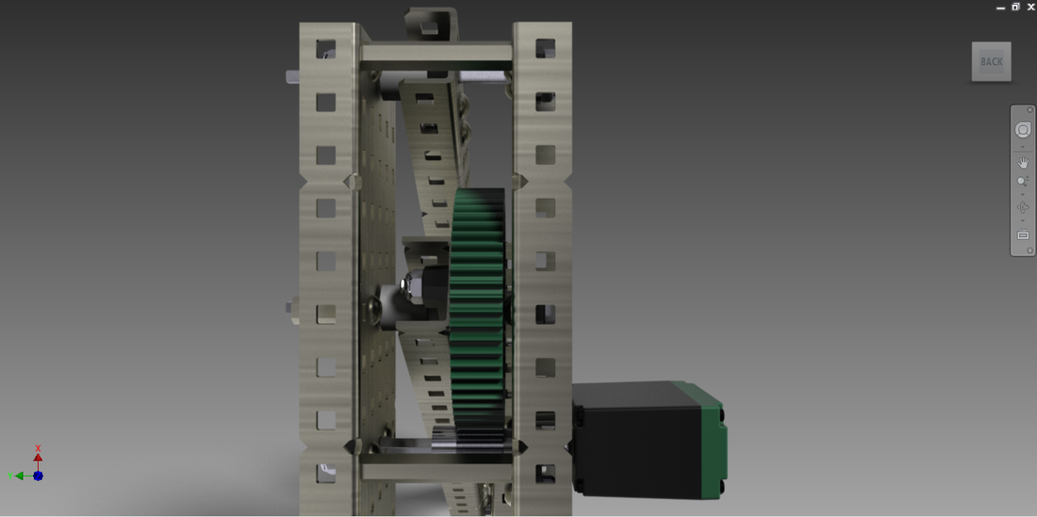

* 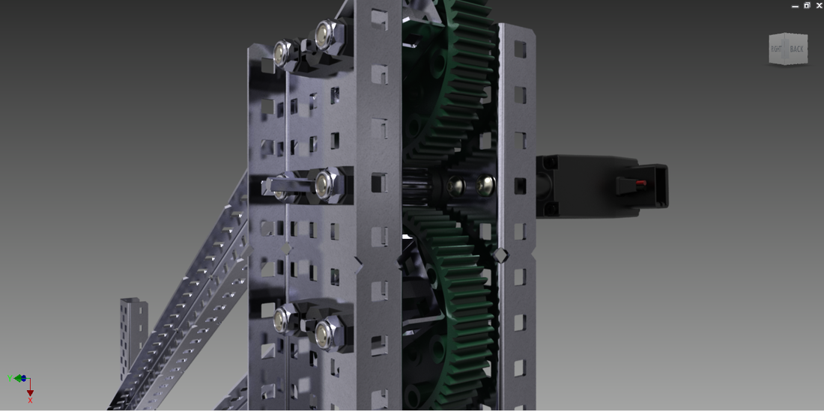**4-Bar Linkage**

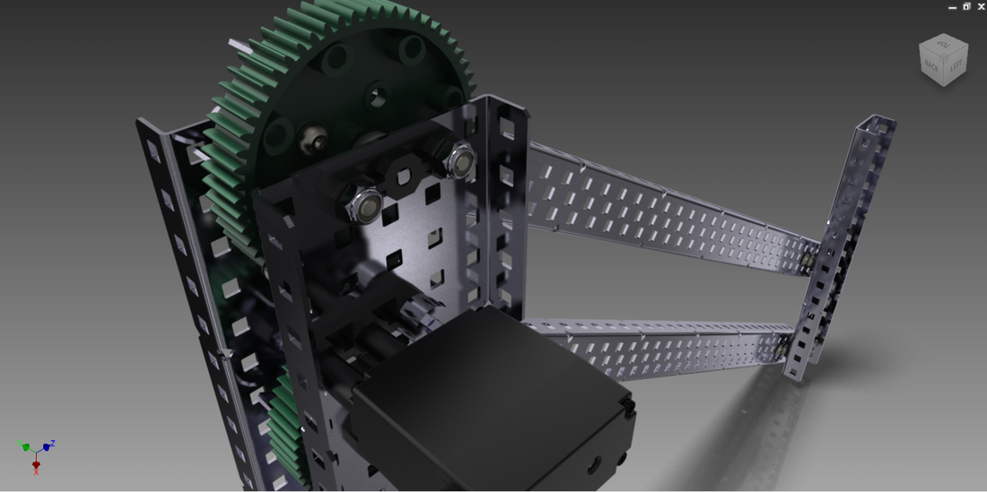

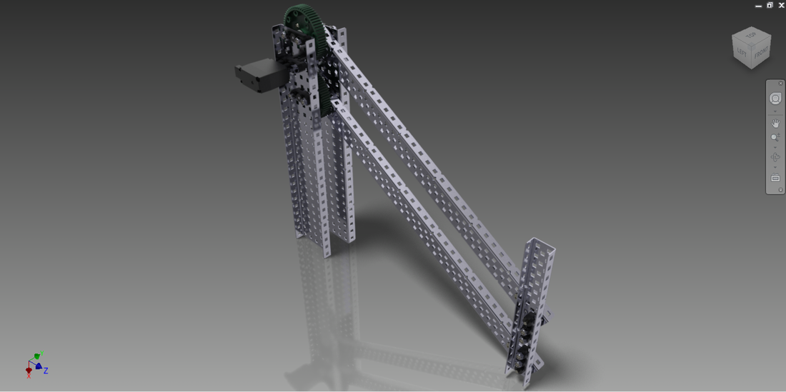

## Further Endeavors

* Create an assembly of our final robot design
* Begin building the chassis and the drivetrain

Date 10

## Objectives

* Complete our final robot design in Inventor
* Build the chassis of the robot, derived from the CAD.

## Meeting